GREENWOOD PUBLIC SCHOOL, DD NAGAR, GWALIOR
OUR MOTTO- DEVELOPMENT WITH DELIGHT
Session: (2020-2021)
CLASS - 5th
SUBJECT - MATHS
CHAPTER - 1
Number System
Greatest number. Smallest number
(One digit ) 9. + 1. =10. (Two digit )
(Two digit ) 99. + 1. =100. (Three digit )
(Three digit ) 999. + 1. =1000. (Four digit )
(Four digit ) 9999. + 1. =10000. (Five digit )
(Five digit ) 99999 + 1. =100000. (Six digit )
(Six digit ) 999999 + 1. =1000000(Seven digit )
so on........
Indian system of numeration
The Indian numbering system is used in the Indian subcontinent to express large numbers.
We can read a 6 digit number sa. 6 7 8 9 0 2 using the place value chart as shown below
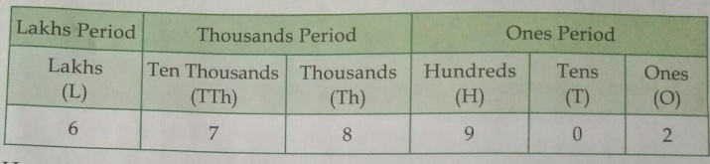
We can we can read it as "six lakh seventy eight thousand nine hundred two. "
Place value and face value

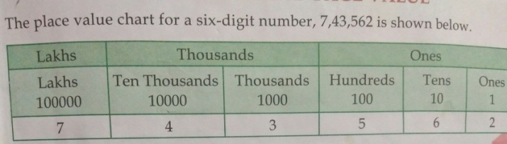
Roman numerals
Roman Numerals | I | V | X | L | C | D | M
Hindu -Arabic Numerals | 1 | 5 | 10 | 50 | 100 | 500 | 1000

Fraction
A fraction is A quantity which expresses a part of the whole quantity
Fraction =Numerator /Denominator
Types of fraction
(a) Proper fraction :-- a fraction in which the numerator is less than the denominator is called a proper fraction.
Exa. 1/2, 6/13,
(b) Improper fraction:- a fraction in which the numerator is greater than the denominator is called an improper fraction .
Exa. 25/6, 16/7
(c) Mixed fraction :-- fraction in fraction which is the combination of natural number and proper fraction is called a mixed fraction.
Exa. 2*1/6
Like and unlike fractions:- fractions with the same denominators are called like fractions and fractions with different denominators are called unlike fractions.

I. e. 1/2 and 6/2 are like fractions
1/2 and 1/3 are unlike fractions
Factors and multiples
Factors :-- A factor is a number which divides the given number exactly .
Example 1,2,3,6,9 and 18 are factor of 18 .
Multiples :-- A multiple of a number is obtained by multiplying it by a natural number.
Example : the multiples of 3 are 3,6,9,12......
LCM and HCF
Least Common factor (LCM)
LCM is a least common number which is divided by all given all numbers
For exa.
Consider the numbers 4 and 6
Multiple of 4: 4,8,12,16,20,24,28,32,36,......
Multiple of 6: 6,12,18,24,30,36,42,48,........
Common multiple of 4 and 6 are 12,24 ,36,.....
LCM =12
Highest common factor :-The number which divides each of the given numbers completely.
For exa.
consider the numbers 42 and 56
Factors of 42: 1,2, 3,7,14, 21, 42
factors of 56 : 1,2,4,7,8 ,14 ,28, 56
Common factors of 42 and 56 are. 1,2, 7 and 14
HCF=14
Decimal
A decimal number can be defined as a number whose whole number part and the fractional part is separated by a decimal we use decimal for Express Mani quantity etc
For example : 45.6 (forty-five point six )
Study the number 9742.412
Thousands | Hundreds | Tens | Ones | Decimal point | Tenths | Hundredths | Thousandths
1000 | 100 | 10 | 1 | . | 1/10 | 1/100 | 1/1000
9 | 7 | 4 | 2 | . | 4 | 1 | 2

Measurement
Largest unit | Standard unit | Smallest unit
Kilogram | Gram | Milligram
Kilometre | Metre | Millilitre
Kilolitre | Litre | Millilitre
Conversion of units.
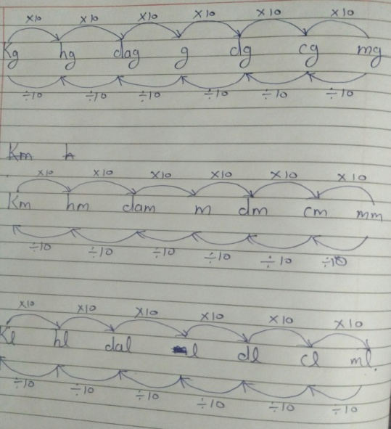
1kg =1000g. 1km =1000m. 1kl = 1000L
1g = 1000mg. 1m = 1000mm. 1 L = 1000ml
1g = 100cg. 1m = 100cm. 1L = 100 cl
Geometry
Square : A polygon which has four equal sides and all angles have 90 degree
Parameter of square : 4x side
Area of square : side X. side

Rectangle : A polygon which opposite sides are equal and all angles have measure 90 degree
Parameter of rectangle : 2(length + breadth)
Area of rectangle : length X breadth

Circle :- A. simple closed curve in which every point have same distance from the centre o.
Diameter = 2r

